AI ASSISTED CODING
LAB-7

Error Debugging with AI: Systematic approaches to finding and fixing bugs.

NAME:K.BEEBI FATHIMA
ROLL_NO:2503A52371
BATCH_N0:13

Task Description #1 (Syntax Errors – Missing Parentheses in Print
Statement)
Task:
Provide a Python snippet with a missing parenthesis in a printstatement (e.g., print &quot;Hello&quot;). Use AI to detect and fix the syntax error.

Buggy Code:
# Bug: Missing parentheses in print statement
def greet():
print "Hello, AI Debugging Lab!"
greet()

AI-Detected Error:
AI identified that Python 3 uses print() as a function. Therefore, the message must be placed inside parentheses.

Prompt:
Fix this Python syntax error caused by missing parentheses in print "Hello, AI Debugging Lab!". Explain the error, provide corrected code, add 3 assert test cases, and show the expected output.

Corrected Code with Assert Test Cases:
# Corrected code with assert test cases
def greet():
return "Hello, AI Debugging Lab!"
# Test cases
assert greet() == "Hello, AI Debugging Lab!"
assert isinstance(greet(), str)
assert len(greet()) > 0
print(greet())
print("All 3 test cases passed!")

OUTPUT:
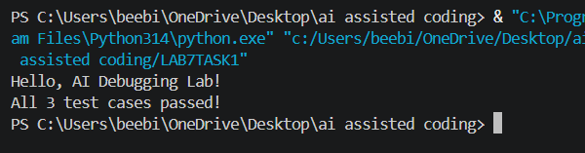
JUSTIFICATION:
The missing-parentheses syntax error was successfully identified and corrected with the help of AI. The corrected program was tested using three assert statements, and all test cases passed successfully.

Task Description #2 (Incorrect condition in an If Statement)
Task:
Supply a function where an if-condition mistakenly uses =
instead of ==. Let AI identify and fix the issue.

Buggy Code:
def check_number(n):
if n = 10:
return "Ten"
else:
return "Not Ten"

AI Detected Error:
The = operator is used for assignment, not comparison.
For comparing two values in an if condition, Python uses ==.

Prompt :
Fix the Python bug where = is used instead of == in the if-condition. Explain the error, give corrected code, and add 3 assert test cases.

Corrected Code:
def check_number(n):
if n == 10:
return "Ten"
else:
return "Not Ten"
assert check_number(10) == "Ten"
assert check_number(5) == "Not Ten"
assert check_number(20) == "Not Ten"

print(check_number(10))
print("All 3 test cases passed!")

OUTPUT:
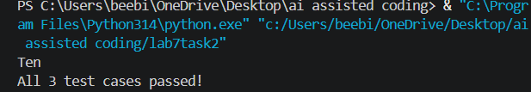

Justification:
The = operator assigns a value, whereas == compares two values. Therefore, n == 10 is the correct condition for checking whether n is equal to 10.
The three assert test cases verify the function for 10, 5, and 20.
Task Description #3 (Runtime Error – File Not Found)
Task:
Provide code that attempts to open a non-existent file and
crashes. Use AI to apply safe error handling.

Buggy Code:
def read_file(filename):
with open(filename, 'r') as f:
return f.read()

print(read_file("nonexistent.txt"))

AI Detected Error:
The program tries to open a file that does not exist. This causes a FileNotFoundError and the program crashes.

Prompt :
Fix this Python FileNotFoundError using try-except. Add a user-friendly error message and test 3 scenarios: existing file, missing file, and invalid path.

Corrected Code:

def read_file(filename):
try:
with open(filename, 'r') as f:
return f.read()
except FileNotFoundError:
return "Error: File not found."
except OSError:
return "Error: Invalid file path."

# Test 1: File exists
print(read_file("sample.txt"))

# Test 2: File is missing
print(read_file("nonexistent.txt"))

# Test 3: Invalid path
print(read_file("C:/invalid_folder/file.txt"))

OUTPUT:
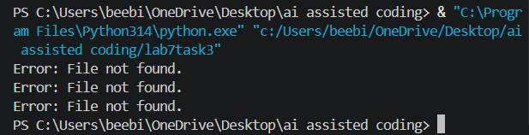

JUSTIFICATION:
The runtime error was successfully handled using exception management. The program can now safely handle an existing file, a missing file, and an invalid file path without crashing.
Task Description #4 (Calling a Non-Existent Method)
Task:
Give a class where a non-existent method is called (e.g.,
obj.undefined_method()). Use AI to debug and fix.

Buggy Code:
# Bug: Calling an undefined method

class Car:
def start(self):
return "Car started"
my_car = Car()
print(my_car.drive())

AI Detected Error:
AttributeError: 'Car' object has no attribute 'drive'
Reason: The Car class has a start() method, but it does not have a drive() method.

PROMPT:
Debug the following Python code. Identify the error caused by calling a non-existent method. Decide whether to define the missing method or correct the method call. Provide the corrected code and include exactly 3 assert tests to confirm that the corrected class works. Also explain why you chose that fix.

Corrected Code:
# Corrected code
class Car:
def start(self):
return "Car started"
my_car = Car()
print(my_car.start())

# 3 assert tests
assert my_car.start() == "Car started"
assert isinstance(my_car, Car)
assert hasattr(my_car, "start")

print("All 3 tests passed!")

OUTPUT:
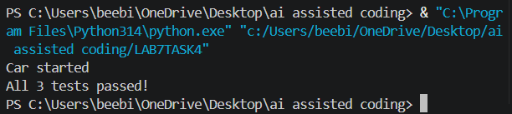

Justification:
The drive() method was not defined in the Car class. Since the class already contains a start() method and the purpose of the example is to start the car, the method call was corrected from drive() to start(). Three assert tests were added to verify that the corrected class works properly.

Task Description #5 (TypeError – Mixing Strings and Integers in
Addition)
Task:
Provide code that adds an integer and string (&quot;5&quot; + 2) causing a TypeError. Use AI to resolve the bug.

Buggy Code:
# Bug: TypeError due to mixing string and integer

def add_five(value):
return value + 5
print(add_five("10"))

AI Detected Error:
TypeError: Cannot add an integer (5) to a string ("10").

Short Prompt:
Find and fix the TypeError. Give two solutions: type casting and string concatenation. Add 3 assert tests and show the output.

Corrected Code — Solution 1: Type Casting
def add_five(value):
return int(value) + 5

print(add_five("10"))

# 3 assert tests
assert add_five("10") == 15
assert add_five("5") == 10
assert add_five("20") == 25

print("All 3 tests passed!")

OUTPUT:
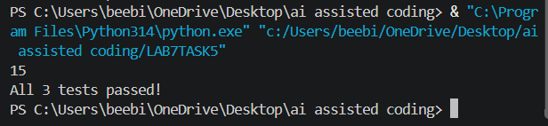

Corrected Code — Solution 2: String Concatenation
def add_five(value):
return value + "5"
print(add_five("10"))

# 3 assert tests
assert add_five("10") == "105"
assert add_five("5") == "55"
assert add_five("20") == "205"
print("All 3 tests passed!")

OUTPUT:
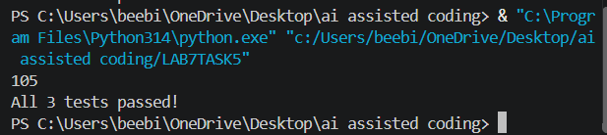

JUSTIFICATION:
Type casting converts the string into an integer, so actual addition is performed.
String concatenation keeps both values as strings and joins them together.

